Advanced Database Training
2026
Vaishnavi Kamthe

Assignment 3a
1. Write a query to rank countries based on the Sales column. E.g. The country with highest Sales value will have first rank and the country with least Sales value will have lowest rank.
SELECT country, sales,
RANK() OVER (ORDER BY sales DESC) AS sales_rank
FROM sales_by_country;

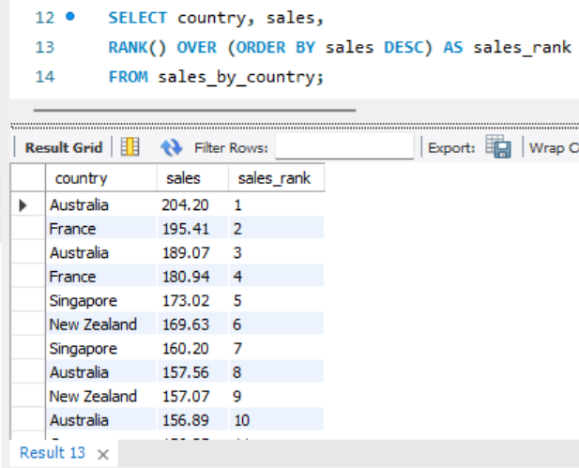
2. Write a query to produce following output:
Country | 2015 | 2016 | 2017 | 2018 |
--------------------------------------------------------------------------------------------------------
Canada 105.23 113.5 136.20 147.0900
SELECT country,
SUM(CASE WHEN year = 2015 THEN sales END) AS '2015',
SUM(CASE WHEN year = 2016 THEN sales END) AS '2016',
SUM(CASE WHEN year = 2017 THEN sales END) AS '2017',
SUM(CASE WHEN year = 2018 THEN sales END) AS '2018'
FROM sales_by_country
GROUP BY country;
